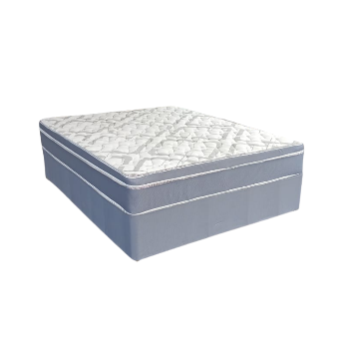
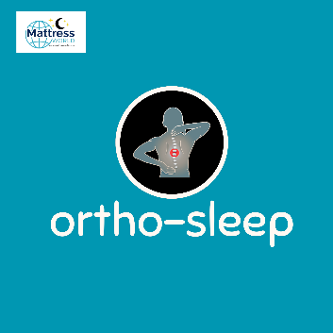

Model : Ortho Top Bed Set
Supplier/Manufacturer : Mattress World
Range : Ortho Sleep Range – All Ortho Sleep Range Mattresses are Orthopedic Design. Made stronger to help improve posture, better quality than average mattresses and keep their shape and feel for a longer period of time. Great quality and good for back support.
Features :
- Hip Support Spring
- Orthopedic Comfort Foam
- Turn Free Design
- 115kg Per Person Per Side
- 1 Year Guarantee
- 15 Year Warranty
- Medium Firm Feel
Prices – Bed Set :
- Single Bed Set – R2499
- Three Quarter Bed Set – R2799
- Double Bed Set – R2999
- Queen Bed Set – R2999
Prices – Mattress Only :
- Single Mattress Only – R1999
- Three Quarter Mattress Only – R2299
- Double Mattress Only – R2499
- Queen Mattress Only – R2499

*This Model is not available in King Size or Extra Length*

